**IT1501 – WEBTECHNOLOGY**

**Assignment 2**

**PROJECT NAME:**

**Sweets shop website**

**(HTML,CSS ,JS,DHTML)**



**BY,**

**NAME:G DURGAGOWRI**

**REG.NO: 312121205055**

**CLASS: IT A**

**COURSE: BTech IT(3rd year)**

**Introduction:**

The purpose of this report is to provide an overview of the website development process for a Sweet website using HTML and CSS along with DHTML and Javascript. The report outlines the key steps taken to create an aesthetically pleasing and user-friendly website for a sweets business.

ABOUT:

This HTML document represents a captivating and visually engaging website for a sweet shop, inviting visitors to indulge in a delightful world of confections. The webpage starts with a striking hero image that immediately captures attention. The hero text encourages users to "Indulge in Delicious Baked Treats" and emphasizes the enjoyment of "Sweet Moments."

The site's top navigation bar features menu links to different sections, including "Cakes," "Ice Cream," "Sweets," "Juices," and "Contact." Each link is complemented by a scrolling pink divider, adding a playful touch to the navigation.

As users scroll down, they encounter a service section that highlights the bakery's offerings. This section uses a grid layout to showcase images and descriptions of services, such as marketing solutions, online store optimization, social media management, and delivery service. The design effectively conveys the range of services offered by the sweet shop, making it easy for users to understand its value proposition.

One of the unique interactive features is the "Change Background Color" button. When clicked, this button dynamically alters the background color of the hero section, adding a fun and interactive element to the website.

Further down the page, there is a section dedicated to the bakery's identity and a call to action. The text proudly declares the shop as the "best bakery in Chennai" and invites users to learn more, encouraging engagement.

The footer is elegantly designed with social media icons for Facebook, Twitter, Instagram, and YouTube, providing users with links to connect with the sweet shop on various platforms.

Overall, this website blends aesthetics and functionality seamlessly. It leverages captivating visuals, interactive elements, and clear navigation to create an immersive experience for visitors. Whether users are exploring the sweet offerings or seeking more information, this web page effectively conveys the essence of the sweet shop and encourages them to connect and explore further.

we have created a simple web project that demonstrates the use of JavaScript to dynamically change the background color of an HTML element. Here's a recap of what we've done:

*HTML Structure: We set up a basic HTML document with an <h1> element and a <button> element.

*CSS Styling: We added some CSS styles to provide initial styling to the <h1> element, giving it a light blue background.

*JavaScript Function: We defined a JavaScript function called changeBackgroundColor that uses the querySelector method to select the <h1> element and change its background color to purple when called.

*Button Interaction: We associated the changeBackgroundColor function with the button's onclick attribute. When the button is clicked, the function is triggered.

*User Interaction: As a result, when a user clicks the "Change Background" button, the background color of the <h1> element dynamically changes to purple.

Program code:

Bakery.html:

<!DOCTYPE html>

<html>

<head>

<meta charset="ISO-8859-1">

<title>Sweet shop</title>

<link rel="stylesheet" href="css/bootstrap.css">

<link rel="stylesheet" href="https://cdnjs.cloudflare.com/ajax/libs/font-awesome/5.15.3/css/all.min.css">

<style>

body {

font-family: Arial, sans-serif;

}

#app {

text-align: center;

margin-top: 50px;

}

button {

padding: 10px 20px;

font-size: 16px;

background-color: #007bff;

color: #fff;

border: none;

cursor: pointer;

}

</style><style>

.change-background-button {

background-color: #ffcccc;

border: none;

padding: 10px 20px;

color: white;

font-size: 18px;

cursor: pointer;

}

body {

background-position: center;

margin-bottom: 50px;

}

.container {

max-width: 100%;

padding: 0 20px;

margin: 0 auto;

}

.header {

background-color: #ffcccc;

color: #fff;

text-align: center;

padding: 20px;

margin: 0px;

}

.top {

overflow: hidden;

background-color: rgb(25, 10, 25);

color: #fff;

}

.top a {

float: left;

display: block;

color: #fff;

padding: 14px;

text-decoration: none;

}

.top a:hover {

background-color: #555;

color: white;

}

.image-container {

display: grid;

grid-template-columns: repeat(4, 1fr);

gap: 10px;

justify-items: center;

margin: 20px 0;

}

.image-container img {

height: 200px;

width: 200px;

margin: 0 10px;

box-shadow: 0 0 5px rgba(0, 0, 0, 0.3);

}

#h2 {

color: black;

}

#h5 {

color: white;

}

h2 {

color: white;

margin-top: 10px;

}

.content {

background-image: url('https://tse3.mm.bing.net/th?id=OIP.baHzi2U6sqqN7wQWSPrxTQHaCb&pid=Api&P=0&h=180');

background-repeat: no-repeat;

background-size: cover;

height: 300px;

background-color: #fff;

padding: 20px;

text-align: center;

box-shadow: 0 0 5px rgba(0, 0, 0, 0.3);

}

.hero-image {

background-image: url("https://media.istockphoto.com/id/1319770522/photo/empty-product-stand-podium-pedestal-exhibition-with-palm-trees-and-neon-lights-on-dark.webp?b=1&s=170667a&w=0&k=20&c=-twn-GH8qRQ91KPyLtK_IUzH6EiIKwC7EFHK62whVj0=");

background-color: #cccccc;

height: 500px;

background-position: center;

background-repeat: no-repeat;

background-size: cover;

position: relative;

}

.hero-text {

text-align: center;

position: absolute;

top: 50%;

left: 50%;

transform: translate(-50%, -50%);

color: white;

font-size: 40px;

}

.hero-im{

background-image: url("https://media.istockphoto.com/id/1201519710/photo/3d-rendering-abstract-neon-background-pink-blue-glowing-lines-rays-of-ultraviolet-light-empty.webp?b=1&s=170667a&w=0&k=20&c=9i9i9b7n7yr0N5nZM-AJUzm7htlXtfT4LO4zOTDOwkU=");

background-color: #cccccc;

height: 700px;

background-position: center;

background-repeat: no-repeat;

background-size: cover;

position: relative;

}

.hero-t {

text-align: center;

position: absolute;

top: 50%;

left: 50%;

transform: translate(-50%, -50%);

color: white;

font-size: 40px;font-style:italic;

}

.hero-image {

background-image: url("https://media.istockphoto.com/id/1319770522/photo/empty-product-stand-podium-pedestal-exhibition-with-palm-trees-and-neon-lights-on-dark.webp?b=1&s=170667a&w=0&k=20&c=-twn-GH8qRQ91KPyLtK_IUzH6EiIKwC7EFHK62whVj0=");

height: 500px;

background-position: center;

background-repeat: no-repeat;

background-size: cover;

position: relative;

}

.hero-text {

text-align: center;

position: absolute;

top: 50%;

left: 50%;

transform: translate(-50%, -50%);

color: white;

font-size: 40px;

}

.hero-text h5 {

font-size: 24px;

color: #ffcccc;

}

.video-container {

position: relative;

width: 100%;

padding-bottom: 56.25%; /* 16:9 aspect ratio (change this value if needed) */

height: 0;

overflow: hidden;

}

.video-container iframe {

position: absolute;

top: 0;

left: 0;

width: 100%;

height: 100%;

}

.hero-text button {

background-color: #ffcccc;

border: none;

padding: 10px 20px;

color: white;

font-size: 18px;

cursor: pointer;

}

.footer {

background: black;

padding: 20px;

color: white;

text-align: center;

}

#dec{

text-decoration:none;

}

</style>

</head>

<body>

<div class="top">

<a href="cakes.html">Cakes<marquee behavior="scroll" direction="left">

<hr style="border-color: pink;">

</marquee>

</a>

<a href="">Ice cream<marquee behavior="scroll" direction="left">

<hr style="border-color: pink;">

</marquee>

</#a>

<a href="Sweet.html">Sweets<marquee behavior="scroll" direction="left">

<hr style="border-color: pink;">

</marquee>

</a>

<a href="#">Juices<marquee behavior="scroll" direction="left">

<hr style="border-color: pink;">

</marquee>

</a>

<a href="contact.html">Contact<marquee behavior="scroll" >

<hr style="border-color: pink;">

</marquee>

</a>

</div>

<div class="hero-image">

<div class="hero-text">

<h3 style="font-size:50px">Indulge in Delicious Baked Treats</h3>

<h5>Enjoy Sweet Moments...</h5>

<!-- Add a button with an onclick event -->

<button class="change-background-button" onclick="changeBackgroundColor()">Change Background Color</button>

</div>

</div>

<center><h1>SERVICES</h1></center>

<div class="container">

<div class="image-container">

<div class="image-item">

<img src="https://images.unsplash.com/photo-1434626881859-194d67b2b86f?ixlib=rb-4.0.3&ixid=M3wxMjA3fDB8MHxzZWFyY2h8Mjd8fG1hcmtldGluZ3xlbnwwfHwwfHx8MA%3D%3D&auto=format&fit=crop&w=600&q=60">

<div class="image-content">

<h3>Sweet Treats Marketing</h3>

<p>Get sweet success with our tailored marketing solutions designed to highlight your best bakery creations.</p>

</div>

</div>

<div class="image-item">

<img src="https://media.istockphoto.com/id/1206800961/photo/online-shopping-and-payment-man-using-tablet-with-shopping-cart-icon-digital-marketing.webp?b=1&s=170667a&w=0&k=20&c=RT5aV_p3DgMk16-QH26DmzNj_uHaq7hkKR0UapnHL2I=">

<div class="image-content">

<h3>Online Store Optimization</h3>

<p>Attract more customers with our e-commerce strategies and optimize your bakery's online store for maximum sales.</p>

</div>

</div>

<div class="image-item">

<img src="https://images.unsplash.com/photo-1491951931722-5a446214b4e2?ixlib=rb-4.0.3&ixid=M3wxMjA3fDB8MHxzZWFyY2h8MTh8fG1hcmtldGluZ3xlbnwwfHwwfHx8MA%3D%3D&auto=format&fit=crop&w=600&q=60">

<div class="image-content">

<h3>Social Media Management</h3>

<p>Boost your online presence and engage with your audience with our professional social media management services.</p>

</div>

</div>

<div class="image-item">

<img src="https://media.istockphoto.com/id/1137764161/photo/close-up-of-delivery-man-handing-a-slack-of-foam-lunch-box.webp?b=1&s=170667a&w=0&k=20&c=udwjtdDwxPGqYcmBFm-FC8gRXZrR2kEwMusBwtXmHvo=">

<div class="image-content">

<h3>Delivery Service</h3>

<p>Fastest Service.Wont let the customer wait for their food.</p>

</div>

</div>

</div>

</div>

<div class="hero-im">

<div class="hero-t">

<div id="app">

<p id="changeText"><h6>We are the best bakery in Chennai!A highly recommend trying their eggless cakes<h6></p>

<button id="changeButton"Style="background-color:#fff;color:pink;height:40px;">Know More</button>

</div>

</div>

</div>

script src="https://cdnjs.cloudflare.com/ajax/libs/font-awesome/5.15.3/js/all.min.js"></script>

<script>

function changeBackgroundColor() {

var h1Element = document.querySelector("h1");

h1Element.style.backgroundColor = "purple"; // Change the background color to purple

}

</script>

<script>

const changeButton = document.getElementById('changeButton');

const changeText = document.getElementById('changeText');

changeButton.addEventListener('click', () => {

changeText.textContent = '**Here Sweets, Cakes, Ice creams, and Juices are available**';

});

</script></body></html>

Output:

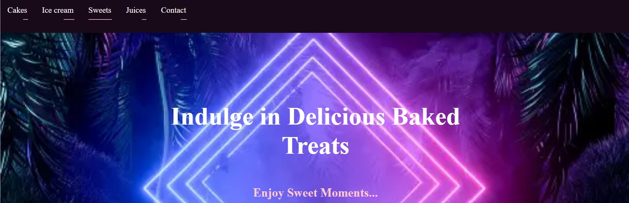//color of services changed by DHTML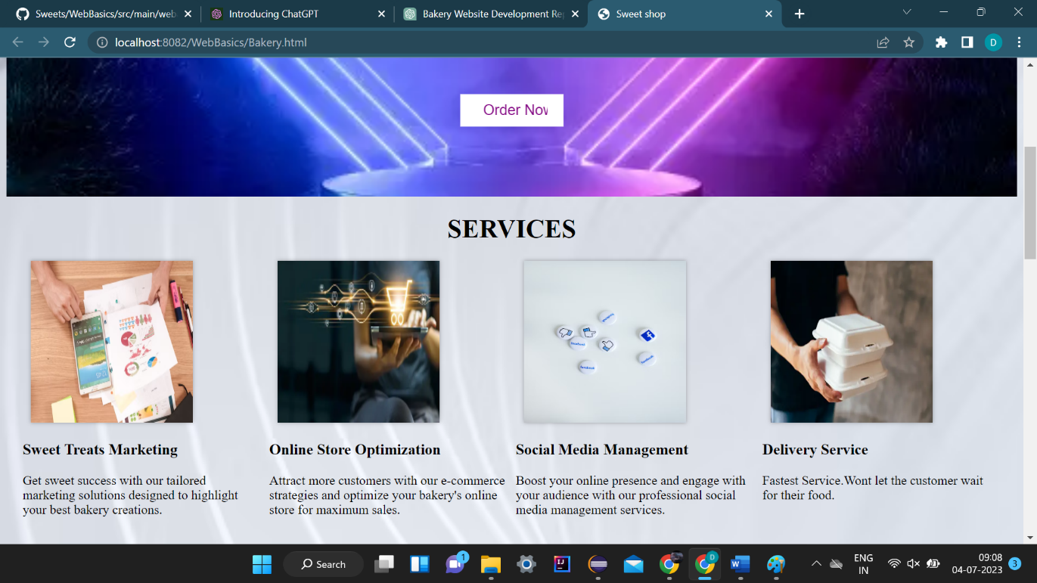

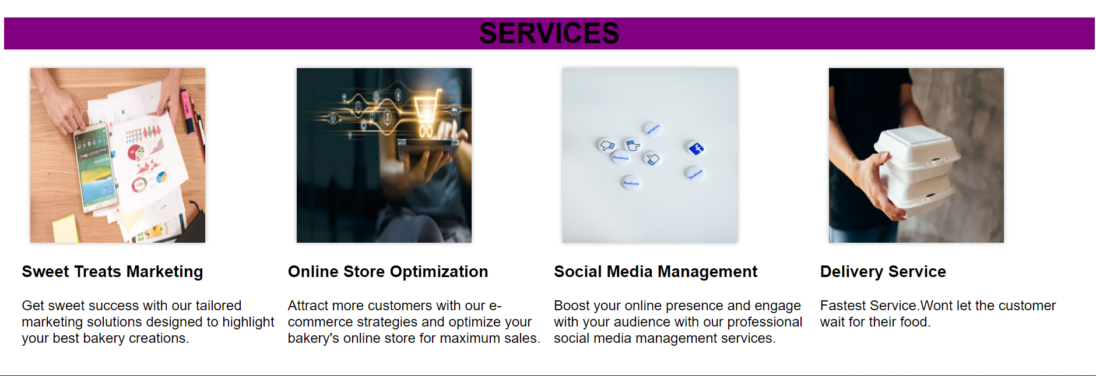

//text inside image changed by DHTML 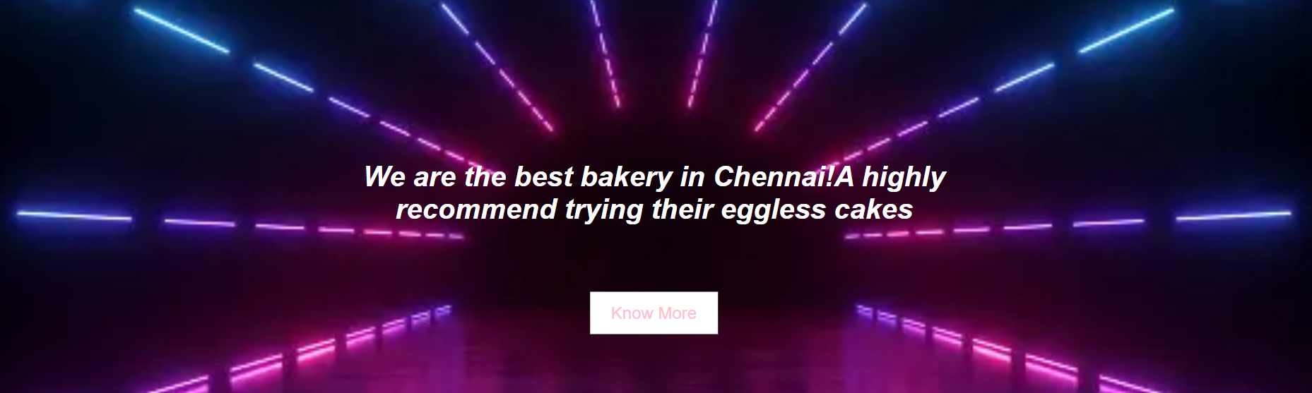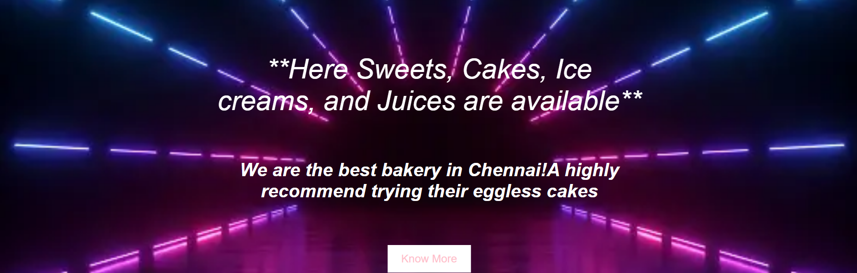

Conclusion:

In this project, we successfully demonstrated the power of web development by creating a basic interactive web page. By combining HTML, CSS, and JavaScript, we achieved the dynamic change of the background color of an HTML element in response to a user's action. This project serves as a foundational example of how small but impactful interactions can be effortlessly added to web content. As web development offers endless possibilities, this project provides a stepping stone for more complex and feature-rich applications in the ever-evolving world of web technology.